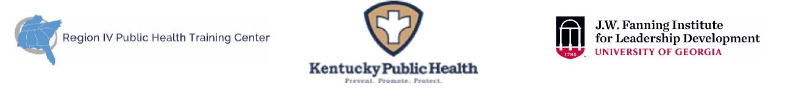
Supervisor Endorsement Form (Rev. 08-09-2022)
(To be completed and signed by Applicant’s Supervisor)

As the supervisor of , I have read the description and participant expectations of the 2022-2023 KY Public Health Leadership Institute (KY-PHLI). If the applicant is selected, I agree to all of the following:

- I will allow time off from regularly assigned duties for her/him to participate in all required activities of the 8-month KY-PHLI experience including: (~ 50 total hours)
  - In-person opening retreat (December 6 – 8, 2022; est. 17 hours) *
  - Six virtual sessions (est. 13 hours)
  - Intersession activities (est. 15 hours)
  - In-person closing retreat (May 31 – June 1, 2023; est. 8 hours) *
Time Period | Activity
September 12, 2022 | Application Deadline
By mid-October 2022 | Selection Notifications
November 15, 2022, 10-12 pm ET | Virtual Orientation
December 6 - 8, 2022 | In-person Opening Retreat*
January 2023 – May 2023  Thursdays @ 10-12:00 pm ET | Virtual Sessions:  Jan 12, Feb 9, Mar 9, Apr 6, May 11
May 31 – June 1, 2023 | In-person Closing Retreat*: Report, Reflect, Graduate
* If conditions do not allow safe travel, the retreats will be virtual during the same timeframes.
- I will encourage the participant’s use of newly developed knowledge, skills, attitudes, and competencies in her/his work.

In what ways do you hope this applicant’s participation will benefit your team or organization?

Print or Type Supervisor Contact Information:

Name:
Position/Title:
Organization Name:
E-mail Address:
Telephone Number:

Signature: ______________________________________________ Date: ________
A typed signature is acceptable.

