
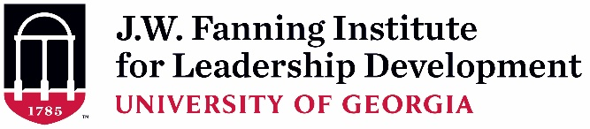

Supervisor Endorsement Form (Rev. 6-23-2022)
(To be completed and signed by Applicant’s Supervisor)

As the supervisor of , I have read the description and participant expectations of the 2022-2023 Region IV Public Health & Primary Care (PHPC) Leadership Institute. If the applicant is selected, I agree to all of the following:

- I will allow time off from regularly assigned duties for her/him to participate in all required activities of the 8-month PHPC Leadership Institute experience including: (~ 40 total hours)
  - In-person opening retreat (October 31 – November 2, 2022; if travel is not safe, there will be a virtual opening retreat October 31 – November 3, 2022, est. from 12 – 3 pm ET) and virtual sessions (est. 12 hours).
  - Intersession activities (est. 16 hours)
Time Period | Activity
October 11, 2022 10-11:30am ET | Virtual Orientation
October 31 – November 2, 2022 * | In-person PHLI Retreat  *If travel is not safe, Virtual Retreat October 31 – November 3 (est. 12-3pm ET)
December 2022 – May 2023  Tuesdays @ 10-12:00pm ET | Virtual Sessions:  Dec 6, Jan 10, Feb 7, Mar 7, Apr 4, May 9

- I will encourage the participant’s use of newly developed knowledge, skills, attitudes, and competencies in her/his work.

In what ways do you hope this applicant’s participation will benefit your team or organization?

Print or Type Supervisor Contact Information:

Name:
Position/Title:
Organization Name:
E-mail Address:
Telephone Number:

Signature: ______________________________________________ Date: ________
A typed signature is acceptable.

