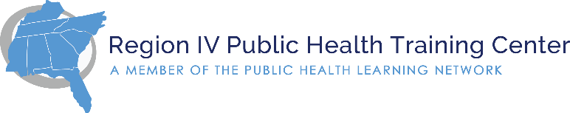
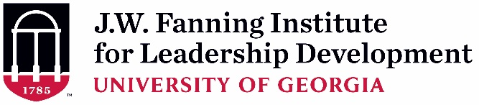

Supervisor Endorsement Form (Rev. 7-11-20)
(To be completed and signed by Applicant’s Supervisor)

As the supervisor of , I have read the description and participant expectations of the 2020-2021 Region IV Public Health Leadership Institute. If the applicant is selected, I agree to all of the following:

- I will allow time off from regularly assigned duties for her/him to participate in all required activities of the 8-month PHLI experience including: (estimated to be 40 total hours)
  - Virtual retreat (est. 16 hours Nov. 2-6, 2020) and virtual sessions (est. 12 hours)
  - Intersession activities (est. 12 hours)
Time Period | Activity
October 13, 2020 10-11:30am ET | Virtual Orientation
November 2-6, 2020 * | Virtual PHLI Session 1 Retreat (est. 12-3pm ET)
December 2020 – May 2021  Tuesdays @ 10-11:30am ET | Virtual Sessions:  Dec 1, Jan 12, Feb 2, Mar 2, Apr 6, May 4
May 4, 2021 | Final Virtual Session @ 10-11:30am ET
* Due to travel safety, a virtual retreat will be held Nov 2-6, 2020 from approximately 12-3pm ET. More information will be available in September for those that are accepted. An in-person meeting may be considered in the future, travel safety permitting.

- I will encourage the participant’s use of newly developed knowledge, skills, attitudes, and competencies in her/his work.

In what ways do you hope this applicant’s participation will benefit your team or organization?

Print or Type Supervisor Contact Information:

Name:
Position/Title:
Organization Name:
E-mail Address:
Telephone Number:

Signature: ______________________________________________ Date: ________

A typed signature is acceptable.

